NOVEMBER 9 & 10, 2019

Dear Pacific Grove Neighbor:

The 16th Presentation of the Monterey Bay Half Marathon (formerly called the Big Sur Half Marathon on Monterey Bay) is coming to town on Sunday, November 10, 2019 along the scenic PG waterfront and through the downtown area. On Saturday morning, November 9, we'll also be featuring our successful fun runs, the Pacific Grove Lighthouse 5K and our By the Bay 3K on a beautiful waterfront-only route from Lovers Point to Pt. Pinos.

Below is a map of the race routes through PG. On the back side we have included parking restrictions and street closure times during the morning hours of race weekend. This information and a full course map including the Monterey section, can also be found on our website, www.montereybayhalfmarathon.org.

Each year we work closely with Pacific Grove staff and public safety to minimize any inconvenience these events may impose on our residents. We hope race weekend is an exciting and enjoyable experience for participants and spectators alike. We encourage you to come cheer on the runners and listen to the variety of musical groups we have placed along the course. We also welcome your participation in our Saturday shorter distance fun runs – registration is available online or during the event weekend.

We appreciate your cooperation, patience, and understanding. This event is organized by the non-profit Big Sur Marathon Foundation. We work hard to execute successful events so that we can give back to charities in the community. If you have any questions or need further information, please call the Big Sur Marathon Foundation office at 625-6226.

Sincerely,
The Board & Staff of the Big Sur Marathon Foundation

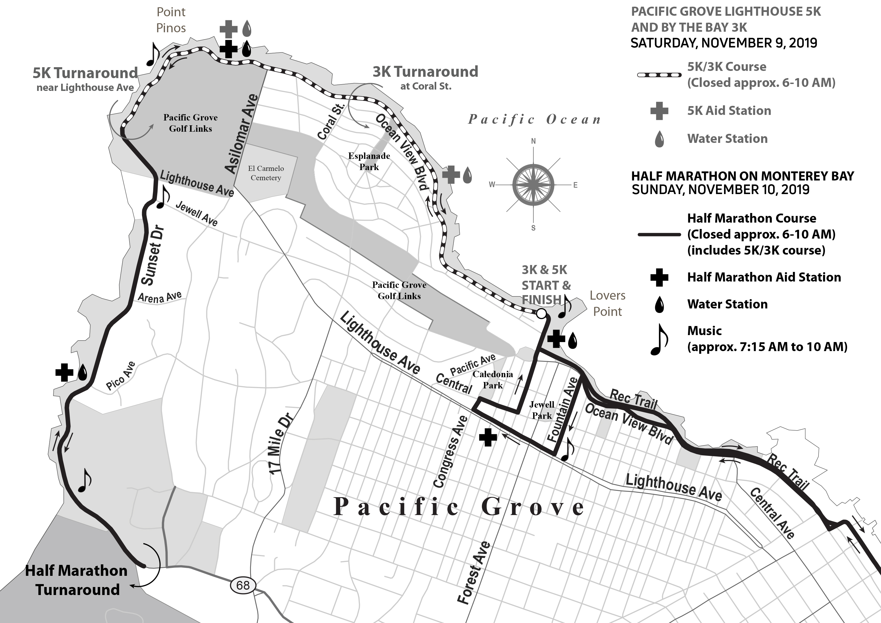

STREET ACCESS AND PARKING FOR THE HALF MARATHON AND RELATED EVENTS Saturday, November 9 and Sunday, November 10

SATURDAY, NOVEMBER 9 – 3K & 5K

Parking Restrictions:
- No parking from 4 a.m. to 10 a.m. along the waterfront on Ocean View Blvd. between 17th (Lovers Point area) and the ocean end of Lighthouse Avenue at the Pacific Grove Golf Links.

Street Access:
- During the course of the event, from approximately 6 a.m.-10 a.m. the road will be closed in both traffic directions on the waterfront on Ocean View Blvd. and Sunset Drive from Lovers Point to Pt. Pinos. Residents who live along Ocean View that may need to exit during the race should pre-park a vehicle on a nearby side street for egress.

- Residents along Mermaid Street and guests of Borg’s Motel and Lovers Point Inn may exit and enter on Mermaid Street at Sea Palm. Vehicles will be allowed to drive against the stated direction in order to exit the area.

SUNDAY, NOVEMBER 10 – Half Marathon

Parking Restrictions:
- No parking on the entire portion of the waterfront from 4 a.m. to 10 a.m. This includes both sides of the street on Ocean View Blvd. and Sunset Drive from Eardley Avenue to Asilomar.

- No parking on the westbound side of Lighthouse Ave. between Fountain and Congress; on either side of the street on Fountain Avenue between Ocean View and Lighthouse; on 17th Street from Ocean View to Central; and on Central Ave. from Congress to 17th Street from 4 a.m. to 9 a.m.

Street Specific Information and Access:
- During the course of the event, from approximately 6 a.m.-10 a.m., the road will be closed in both traffic directions on the waterfront on Ocean View Blvd. and Sunset Drive from Eardley to Sunset Drive near the Fishwife. Residents who live along Ocean View that may need to exit during the race should pre-park a vehicle on a nearby side street for egress.

- Residents along Mermaid Street and guests of Borg’s Motel and Lovers Point Inn may exit and enter (cautiously) on Mermaid Street at Sea Palm only. Vehicles will be allowed to drive against the stated direction, but may not exit on Ocean View Blvd.

- Between the hours of 7:00 a.m. and 8:45 a.m., residents and visitors between Fountain and 16th from Ocean View to Light- house Avenue, will be allowed to exit the area in one location only. The exit area is located at the intersection of Central Avenue and Fountain Avenue (by the Library). Please note: there will likely be delays in exiting this area due to the number of runners crossing at the peak time. NOTE: 17th St. residents will have only pedestrian access from their homes between these hours.

- Between the hours of 7:00 a.m. and 9:00 a.m., residents on 18th, 19th and Caledonia Streets between Jewell and Central Avenues will need to exit via Union or Jewell and leave the area on Pacific Ave. Residents on one-way streets will be allowed to drive against the stated direction in order to exit the area.

SUNSET DRIVE AND ASILOMAR AREA RESIDENTS’ INFORMATION

During the course of the event, from approximately 6:00 a.m.-10 a.m. on Sunday, November 10th, traffic flow on Sunset Drive below Asilomar Blvd will be restricted to vehicles wishing to visit the Beachcomber Inn and Asilomar Conference Grounds. A Pacific Grove Police Department officer will be assigned to the intersection of Sunset and Asilomar Blvd to assure access is maintained to the motel and conference grounds. Residents who live on Sunset Drive between Asilomar Blvd. and Lighthouse needing to leave during the race should pre-park a vehicle on a nearby side street (Lighthouse, Jewell Avenue, Arena or Pico).

BUS INFORMATION

For Monterey Salinas Transit route information affected by the Half Marathon, please call MST at 899-2558.

